|  |  |
| --- | --- |
| Website: [www.harishchandrapurcollege.org.in](http://www.harishchandrapurcollege.org.in) Hello: 8768130356  e-mail: [harishchandrapurcollege2008@gmail.com](mailto:harishchandrapurcollege2008@gmail.com) 9804469759    (Affiliated to the University of Gour Banga), Estd. – 2008   |  | | --- | | **P.O.- Pipla, District- Malda, PIN Code-732125, West Bengal** | |

Memo No.- August/2024/08 Date- 20/08/2024

N O T I F I C A T I O N

Prohibition of Ragging

All students are hereby informed that, in accordance with the University Grants Commission (UGC) Regulations on Curbing the Menace of Ragging in Educational Institutions, 2009, published in the Gazette of India dated 4th July 2009, ragging in any form is strictly prohibited both inside and outside the college premises.

The institution upholds a zero-tolerance policy towards ragging. Any involvement in ragging will be dealt with severely as per the Hon'ble Supreme Court's directives. Appropriate legal action will be taken against any student found involved in ragging activities.

Students are encouraged to report any incidents of ragging to the Anti-Ragging Committee immediately.

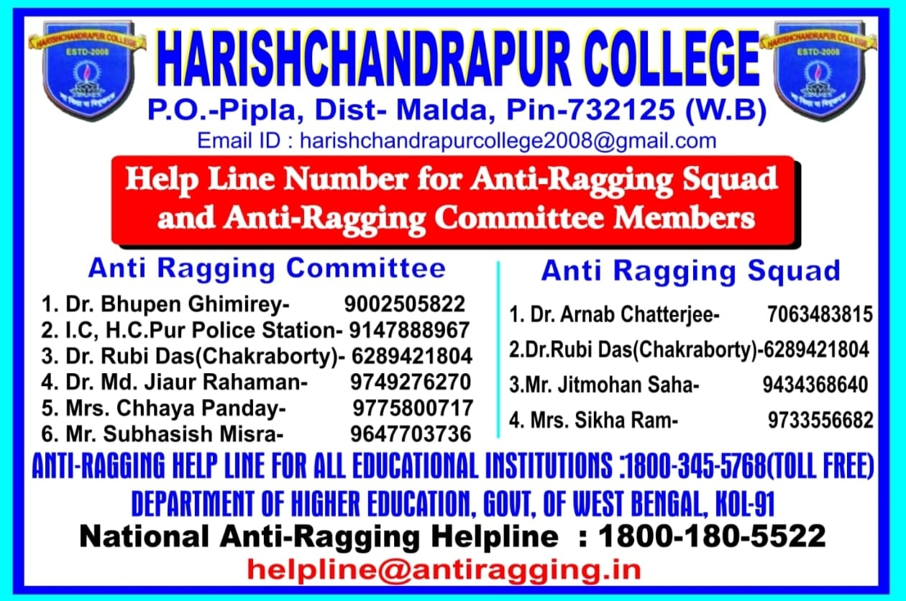

Prof. (Dr.) Sumit Nandi

Principal

Harishchandrapur College, Malda.